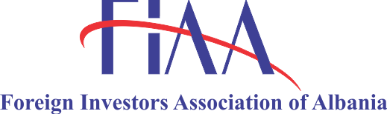
DIGITAL HORIZON ALBANIA 2025

Connecting Albania's Future: Technology as the Engine of Economic Growth

November 5th, 2025 @Tirana Marriott Hotel

DRAFT AGENDA

09:30 – 10:00 Welcoming Remarks

Welcome from the Organizers

Opening Keynote: "The Digital Pulse of the Nation", by Balazs Revesz, President of FIAA

EU Digital Agenda and Growth Plan for Albania (EU Delegation and EU Commission) tbc

Greetings by Delina Ibrahimaj, Minister of Economy and Innovation

10:00 – 10:30 Innovation from the Edge: Global & Regional Insights
The Blueprint for a Digital Nation: Lessons from the World's Best Featuring our Global and Regional Keynote Speaker

Speaker: Anne o’Leary, VP of Mid-Market EMEA META/Ex Vodafone CEO Irland (tbc)

10:30 – 11:30 Panel 1 – The Engine Room: How a Healthy Tech Sector Fuels the Success of Smart Nations
This panel reframes the success stories to highlight the ecosystem technology enables for the country.

Moderator: tbc

Panelists: TP (tbc)

Banking representative (tbc)

Startup community (tbc)

RITECH (tbc)

Intracom Telecom Albania S.A (tbc)

Engineering Albania (tbc)

12:00 - 13:00 Panel 2 – Upskilling in Albania in the Age of AI
This panel focuses on the urgent need to bridge the digital skills gap, to showcase initiatives and partnerships and to display how AI creates new job opportunities.

Moderator: tbc

Panelists: International speaker (tbc)

Representative from the Ministry of Education of Albania (tbc)

Successful Albanian tech entrepreneur who benefited from upskilling initiatives (tbc)

14:00 – 15:00 Panel 3 – Approaching new ICT companies – Pitching for Albania

Moderator: tbc

Panelists: Elira Kokona, Executive Director, Albanian Investment Corporation

TechnoPark (tbc)

Plug & Play (tbc)

Fintech (tbc)

15:00 – 16:00 Matchmaking Between Companies (New & Existing)
This session aims to fostering collaboration, investment, and innovation by bringing together emerging businesses and established companies to explore strategic partnerships that drive growth, competitiveness, and sustainable development.

16:00 Closing Keynote: "The Connected Decade: A Pact for Albania's Prosperity"

Final Reflections: Synthesizing the day's lessons on sector health, innovation, and skills.

